N-Gram

N-Gram Application Exercise: Trigram Probability
Given the following sentence:
text = "I love natural language processing I love machine learning"
Write a Python program to:
- Convert the text into a list of words.
- Create trigrams from the words.
- Count each trigram.
- Count each preceding bigram.
- Calculate the trigram probability using:
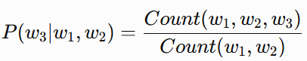
- Display the following for every trigram:
  - Trigram
  - First two words
  - Count of trigram
  - Count of first two words
  - Probability

